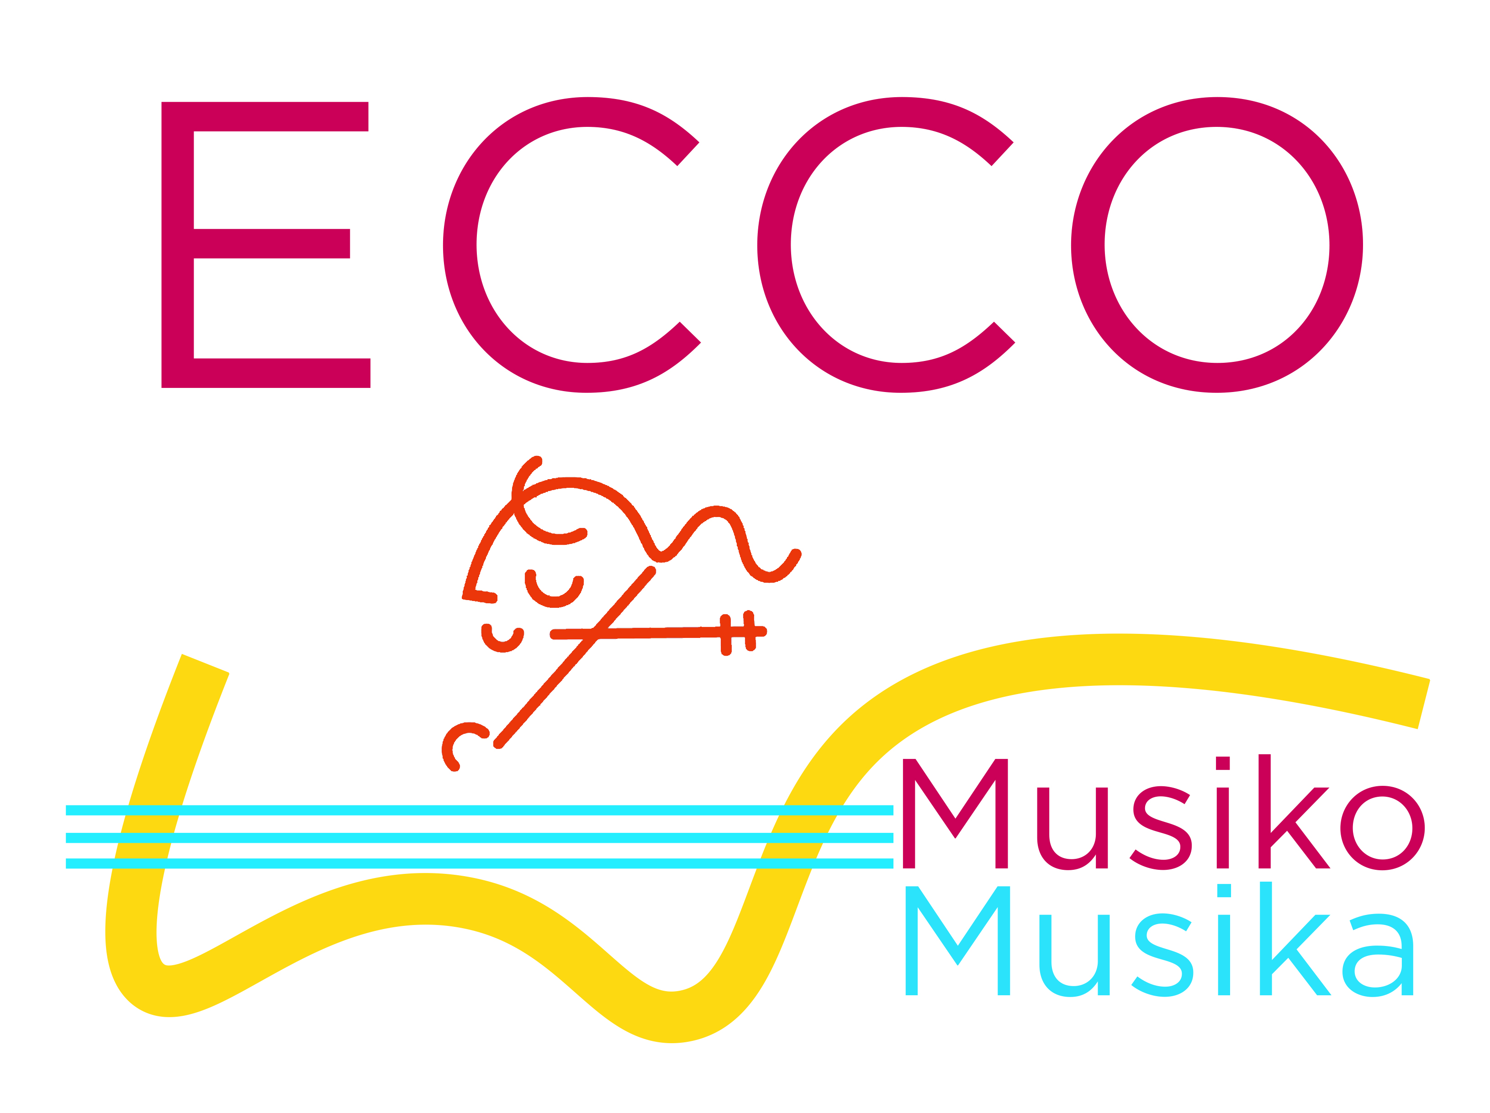

ECCO Term Dates Autumn 2019

Saturday 14th September – First session of term
Saturday 21st September
Saturday 28th September
Saturday 5th October
Saturday 12th October – Concert at St Paul’s Covent Garden (no morning rehearsal)
Saturday 19th October
Saturday 26th October NO SESSION (Half term)
Saturday 2nd November
Saturday 9th November
Saturday 16th November
Saturday 23rd November
Saturday 30th November
Saturday 7th December – Last session of term

Best wishes
Mauricio, Laura and Rachel

